Task 2

1. Chat GPT

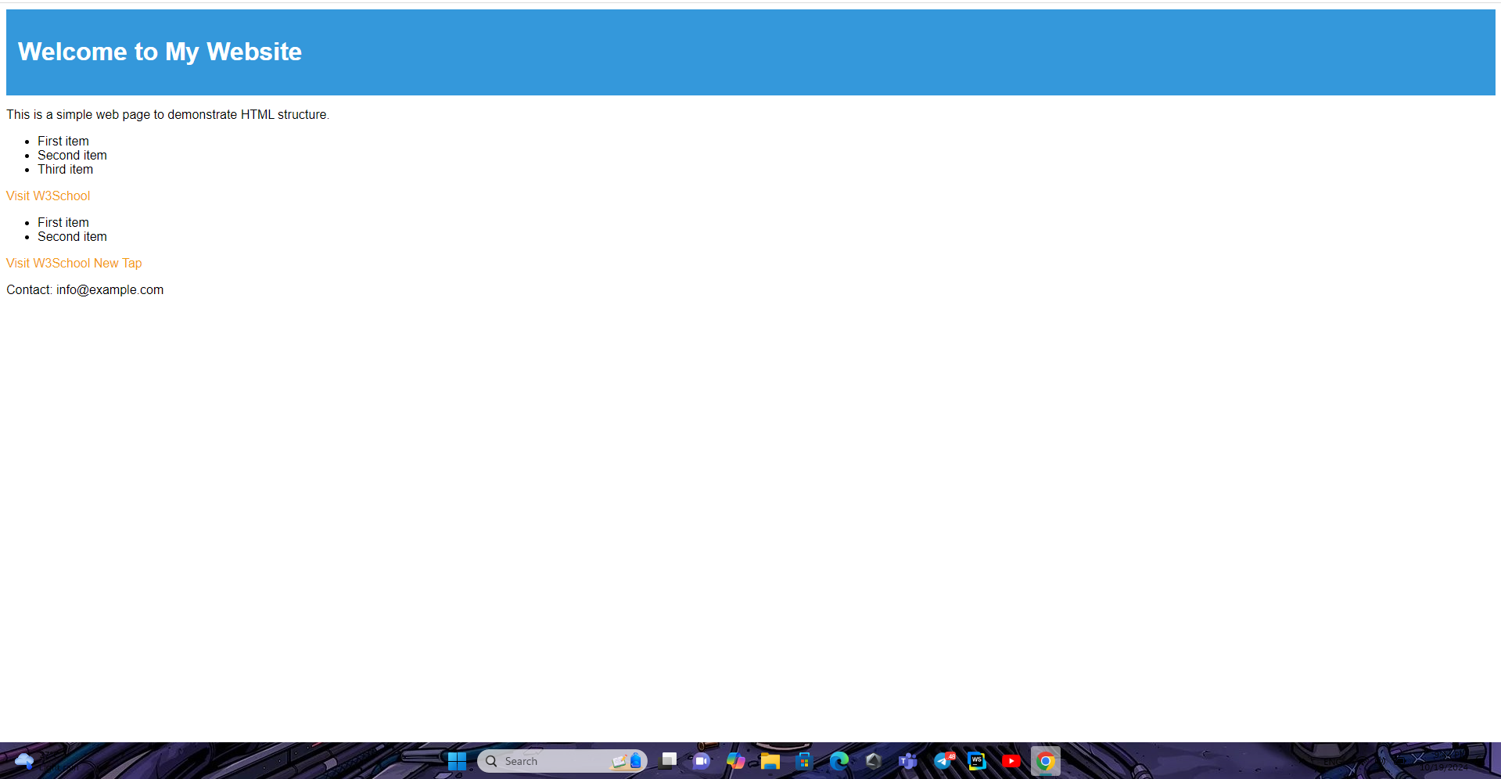

2. Gemini

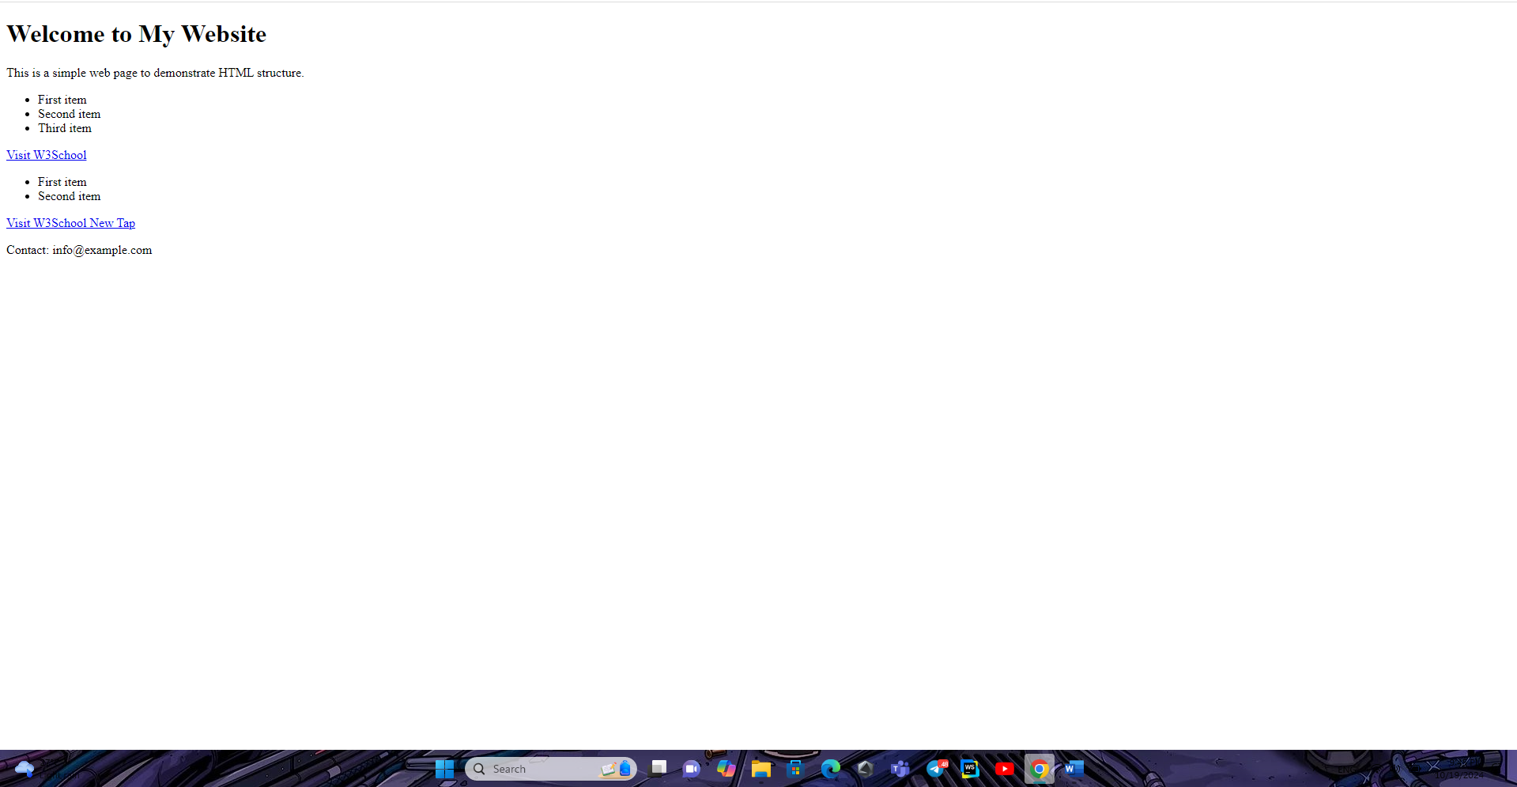

Both follow the prompt.